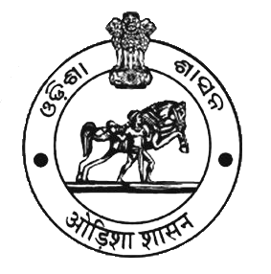
SOP 1: OPD

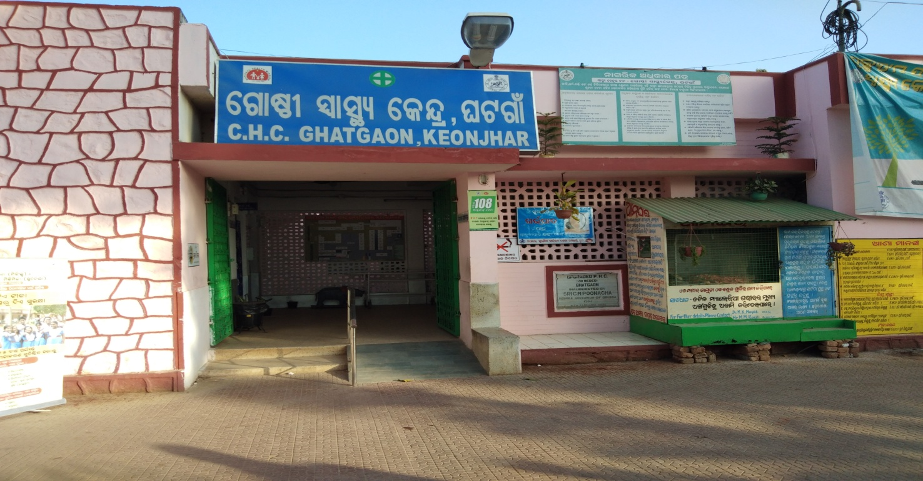

Issue date: 25. 01.2018 Prepared by: State QA cell
Document No. SOP-1
Verified by: | Approved by
MO, CHC Ghatgaon | MO I/C, CHC Ghatgaon

SOP 1: OPD

- Purpose:
- To ensure that all services to outpatients are coordinated so that they get the required care from service providers in the hospital.
- To respond to the need and expectations of the patients and to enhance patient satisfaction.

- Scope:
It covers the persons who visit the OPD facility (new and follow up patients) for consultation, treatment, investigation, check-up and immunization.

- Responsibility:
- The pharmacist along with MO is responsible for monitoring the respective OPD unit functioning and maintaining necessary records
- The medical officers are responsible for examination of the patients and for determining the line of management of the ailment / case thereof.

- Procedure:

S No | Activity | Responsibility | Ref. Document/ Record
1 | Scope of Services – Hospital provides services as given below:  - General OPD  - AYUSH OPD  - Adolescent OPD (Every Saturday & Monday)  - Accident & Emergency (24X7) | MO I/C
2 | Display of Information- Information regarding OPD clinics available, doctors and their timings and room no. and directional signage for clinics are displayed at the entrance and other relevant locations | MO I/C
3 | OPD REGISTRATION PROCESS  - New Patients go to the registration counter for registration.  - The patient receives the OPD slip with UHID, date and time at the registration counter after submitting the detailed information as applicable)  - Follow up patients go to the registration counter for marking of date and time on the Old OPD slip  - Patient with OPD slip goes to respective doctor for consultation in Consultants room
4 | OPD CONSULTATION PROCESS
 | Initial Assessment  All new patients are assessed initially in the general OPD .all old OPD Patients are provided consultation in the general OPD & registered in the OPD Register maintained by pharmacist.  Patient Calling System -  Patient waits outside concerned doctor room for his/her turn. Patient is called by Doctor/attendant as per his/her turn on the basis of “first come first examine” basis.  For any critical patient needing urgent attention queue can be bypassed for providing services on priority basis.  Receiving the patient in clinic-  Doctor/Attendant greets the patient and guides him to sit on patient stool/chair by his side and not full face across the desk.  No patient is consulted in standing position. If patient is accompanied by relatives/attendant as per hospital policy they are also offered seats. But if patient wants to be consulted alone and/or doctor feels it necessary he asks other to leave the clinic.  History Taking, Physical Examination and Risk Assessment & Differential  Diagnosis-  Doctor assesses the patient and provide treatment as per STG  Doctor notes down the relevant history and examination on the OPD card. The card is signed and stamped with date and time by the doctor  Examination table with footsteps and screens for privacy have been provided in the clinics.  A female attendant / nurse /relative is required to accompany the female patient at the time of examination in the case doctor examining is male | Pharmacist for registration | OPD card
5 | Investigations  In case laboratory/ radiology investigations are required to be performed, investigation are prescribe on investigation slip/ Prescription slip  Only those investigations which are not available in hospital and essential for arriving diagnosis are prescribed for outside.  After the investigation patient come back to OPD for the consultation. | Medical Officer
6 | Drug Dispensing  If medicines are prescribed, the patient goes to the NIRAMAYA Counter to collect it.  The DDC pharmacist issues the medicines and stamp the card with date and time |  | Procedure for  Pharmacy
7 | Follow Up  Cases where follow up visit is required the same is mentioned in the OPD card and the patient / relatives are informed by the doctor  about the date and time for the next follow-up visit. | Medical Officer/  Specialist | OPD Card
8 | Injection and Immunization in OPD
 | In case medical officer prescribe for the Injection or Immunization the patient is directed to injection room cum assessment room  staff on duty administers the injection as instructed by the treating doctor | Staff on duty | Injection Register
9 | Patient Privacy and Confidentiality-  Patients privacy is maintain during all OPDprocedures including consultation, examination, counseling and procedures like  Injection and dressing. Screens and curtains have been provided at all such areas of OPD.  Information and records pertaining to diagnosis and treatment of patients are not shared with anybody except clinical staff  involved in treatment. | MO I/C
10 | Duty Roster – A duty roster is prepared by MO I/C on monthly for deputation of Doctors in OPD.  If Clinic remains unattended information the same is displayed on the notice board. | MO I/C | Duty Roster
11 | Punctuality, Dress Code and Identity  Mo I/C monitors that all the staff are available at their clinic at scheduled time. If any Discrepancy is takes corrective action in this regards  Same measures are also taken for Nursing and support staff.  All the staff wear their respective  uniform/Apron with name plate/ I-Card. | Mo I/C
12 | Disable Friendly OPD  Ramps have been provided at entrance and for other elevated area.  Wheelchairs / Trolleys have been provided on entrance/ reception.  Disable friendly toilets | Mo I/C
13 | Hand Hygiene-  Doctor wash hands between examining two patients with soap following the steps and duration.  Alternately alcohol based hand rub is used for the same.  Hand washing facilities with running water and soap/ Hand rub have been at all point of  use. | Medical Officer in OPD
14 | Clinic Management –  Pharmacist with dental surgeon ensures that all necessary instruments/equipments/furniture/consumables including patient stool, thermometer. BP apparatus, examination table, other examination equipments, hand washing facility, X-ray View box, examination gloves, screens and curtains are available in the clinic before start of day.  Any deficiency is noted and discussed with Mo I/C for corrective action | Dental Surgeon and Pharmacist
15 | Patient Amenities-  Patient amenities like safe drinking water, adequate chairs in waiting area, clean toilets, fan and air cooling/heating are made  available. | MO I/C/Health inspector
16 | Prohibition of Smoking-  Smoking is prohibited in OPD as well other  areas of Hospitals under Prohibition of  Smoking in Public Places rules 2008.  A 60 X 30cm board saying, “No Smoking  Area – Smoking Here is an Offence” is  prominently displayed at each entrance,  floors, staircases, entrance of the lifts and at  Conspicuous place(s) inside. | MO I/C | Prohibition of  Smoking in  Public Places  Rules 2008.
17 | Administrative and non-clinical work at OPD  Administrative work like attestation of certificates and issue of medical certificates are not entertained in the OPD timings  Medical representatives from  pharmaceutical companies are not  entertained in OPD timing.  Notice for the same is displayed at the OPD. | MO I/C
18 | Quality Measures in OPD
- Patient satisfaction survey is conducted on a periodic basis (30 patients per month). Analysis of data collected is done on quarterly basis.
- Prescription Audit is done on a periodic basis (30 patients per month). Analysis of data collected is done on quarterly basis.
- UHID is provided to all patients
- Doctors maintain their respective OPD registers
- Pharmacist collects the data required for reporting of OPD indicators from respective staff of PHC in the prescribed format on daily basis
- Root cause analysis and action planning is done on a periodic basis

- Records

S No | Name of Record | Record No | Minimum Retention period
1 | New Registration register (UHID) | HP /OPD/RC/1 | 1 years
2 | Follow up register (Old) | HP /OPD/RC/2 | 1 years
3 | General OPD register | HP /OPD/RC/3 | 1 years
4 | Obs. & Gyne. OPD register | HP /OPD/RC/4 | 1 years
5 | AYUSH OPD register | HP /OPD/RC/5 | 1 years
6 | Dental OPD register | HP /OPD/RC/6 | 1 years
7 | Injection room register | HP /OPD/RC/7 | 1 years
8 | Dressing room register | HP /OPD/RC/8 | 1 years
9 | MLC Register | HP /OPD/RC/9 | 1 years
10 | Referral register | HP /OPD/RC/10 | 1 years
11 | Police information register | HP /OPD/RC/11 | 1 years
12 | Ambulance register | HP /OPD/RC/12 | 1 years
13 | Dead body carrying register | HP /OPD/RC/13 | 1 years
14 | Accident reporting register | HP /OPD/RC/14 | 1 years
15 | Calibration register | HP /OPD/RC/15 | 1 years

